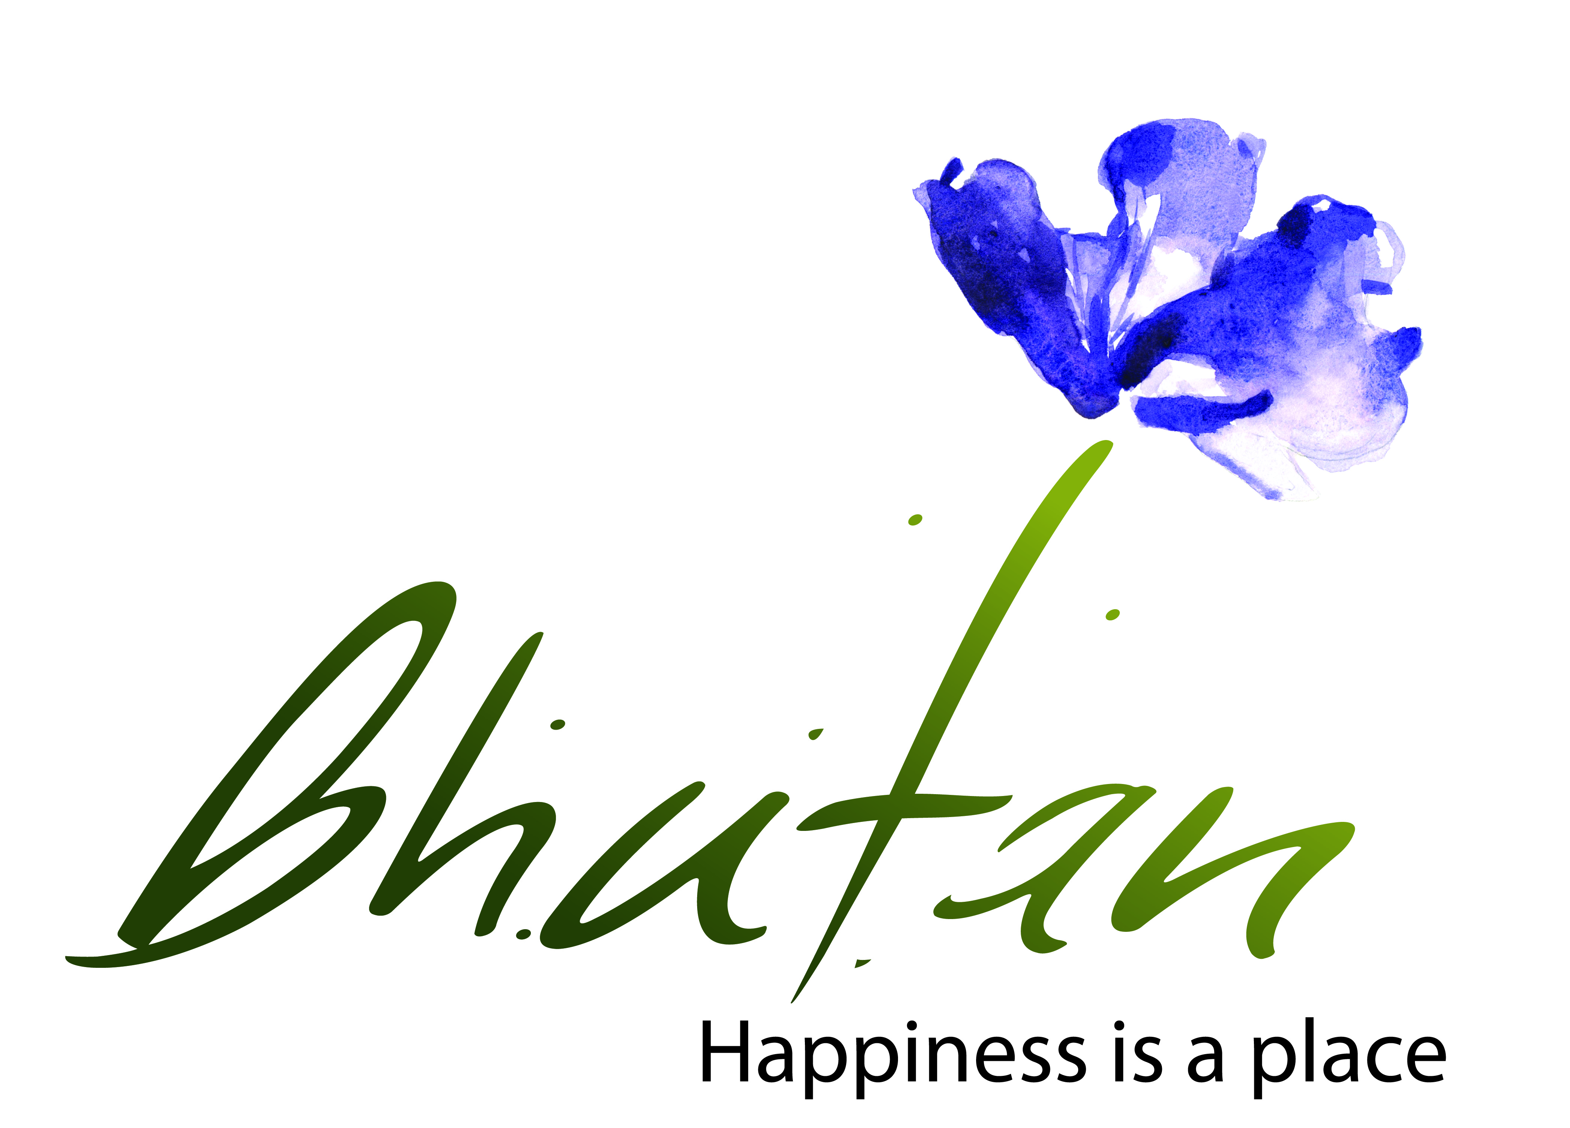 **TOURISM COUNCIL OF BHUTAN**

TOURISM & HOSPITALITY TRAINING

The Tourism Council of Bhutan will be conducting following Tourism & Hospitality related trainings in the month of January, 2019:

1. Professional Cooking Training

2. Professional F&B Services Training

3. Tour Guide Refreshers’ course

4. Specialization Course for tour guides on Birding

For Sl. # 1 & 2, an applicants must be employee of tourist standard accommodations and restaurants and for Sl. # 3 & 4, an applicants must hold a valid Tour Guide license issued by TCB.

Therefore, all concerned are requested to register for the training with the Services Division of TCB. The last date for registration is **31st December, 2018**. Application may be closed before the deadline if seats are filled up. Please contact Mr. Thinley Gyeltshen at 323252 ext. # 210 or visit our website-**www.tourism.gov.bt** for more information and detailed criteria.

………………………………………………………………………………………………

**Documents to be submitted:**

**A: For Hospitality Related Training:**

1. Recommendation letter from respective Hotels & Restaurants nominating for the particular training area.

2. Copy of the Identity Card

3. Security Clearance (online accepted)

4. Any other supporting Certificates in related fields

Submit the documents via email to [training@rith.edu.bt](mailto:training@rith.edu.bt)

**B: For Tourism Related Training:**

1. Duly Filled application form (available on [www.tourism.gov.bt](http://www.tourism.gov.bt) for download)

2. Copy of Valid guide license

3. Security Clearance (online accepted)

4. Security deposit of **Nu. 2,000/- (Ngultrum Two Thousand)** for Specialization course

* Security deposit refundable, T&C applied as per undertaking.

Application form & documents should be submitted in person or contact focal person at [training@tourism.gov.bt](mailto:training@tourism.gov.bt) for further information.

* Preference will be given to those who not availed the similar training in February, 2018 by TCB.
* Any application without complete documents will not be accepted.

**Detailed Training Schedule**

|  |  |  |  |  |  |
| --- | --- | --- | --- | --- | --- |
| **#** | **Field of Training** | **Schedule** | **Eligibility** | **Intake** | **Venue** |
| 1 | Professional Food Production Training | 08th January – 14th January, 2019 | Nominations from any tourist standards hotels & restaurants certified by TCB. | 20 | Royal Institute for Tourism & Hospitality, Upper Motithang, Thimphu |
| 2 | Professional Food & Beverage Services Training | 08th January – 14th January, 2019 | Nominations from any tourist standards hotels & restaurants certified by TCB. | 20 |
| 3 | Tour Guide Refreshers’ course | 09th January- 15th January, 2019 | Tour guide having valid license (Preference will be given to those having minimum 3 years)  Selection will be on first come first basis | 50 |
| 4 | Specialization Course for tour guides on Birding | 08th January – 20th January, 2019 | Tour guide having valid license (Preference will be given to those having minimum 3 years of experience & holding trekking license)  Selection will be on first come first basis | 30 | Royal Institute for Tourism & Hospitality, Upper Motithang, Thimphu and field visit to Zhemgang. |